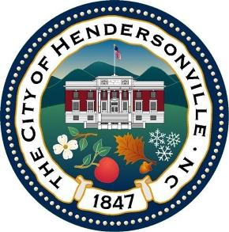

2026 Holiday Garbage, Recycling, and Brush Collection Schedule

Monday | January 19, 2026 | (Collection on the following Monday) | Martin Luther King Jr
Friday | April 3, 2026 | (Collection on the following Friday) | Good Friday
Monday | May 25, 2026 | (Collection on the following Monday) | Memorial Day
Friday | July 3, 2026 | (Collection on the following Friday) | Independence Day
Monday | September 7, 2026 | (Collection on the following Monday) | Labor Day
Wednesday | November 11, 2026 | (Collection on the following Wednesday) | Veteran’s Day
Thursday | November 26, 2026 | (Collection on the following day) | Thanksgiving
Friday | November 27, 2026 | (Regular schedule plus Thursday route) | Thanksgiving
Thursday | December 24, 2026 | (Regular schedule) | Christmas
Friday | December 25, 2026 | (Collection on Monday December 28) | Christmas
Monday  Friday | December 28, 2026  January 1, 2027 | (Regular schedule plus Friday route)  (Collection on the following Friday) | Christmas  New Years Day
We will no longer be collecting garbage, recycling, and brush on Holidays, when practical. Customers will be asked to hold their materials until their next regular collection day. We anticipate extra material for the following week and we plan to collect it (the brush collection schedule may be impacted due to volume).


“Keep Hendersonville Clean”

For questions about garbage, recycling, and brush collection, please visit our web page
www.hendersonvillenc.gov or call (828) 697-3084. We also utilize Facebook to pass along collection updates and notices.

